Workflow Enabled Domain Object Interface:
- Represents Domain entity like expanse which can have different states in domain.
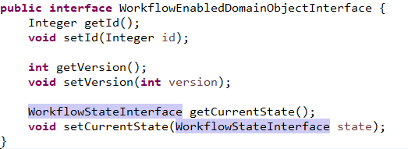
- It contains current state.

Workflow Action:
- Class represents an action that can be performed in a workflow.
- An action can have conditions, that determine of the action can be executed or not.
- The action may also have one or more commands that must be executed as part of performing the action.
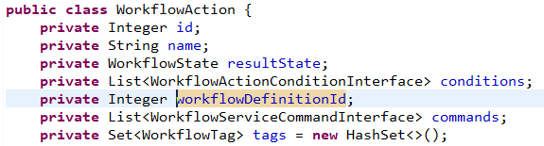
- It contains result Workflow state, List of Workflow conditions, Workflow definition id, workflow commands that needs to be executed, and workflow tags.
Workflow State:
- Class that represents a given state in a workflow.
- Apart from name, and knowledge of the workflow it belongs to, also contains a list of actions that can be executed from the current state.
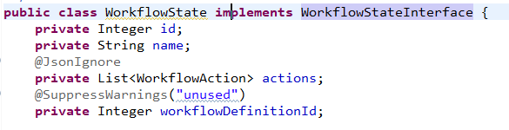

- WorkflowStateInterface contains getId and getName methods.

Workflow Action Condition Interface:
- This class implementing this interface represents condition for executing Actions

- Implementing Class can also contain other condition methods.

Workflow Service Command Interface:
- Represents command used in action.
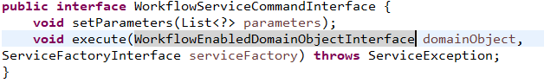
- .

Workflow Tag:
- It is enum containing name of all states of domain object.
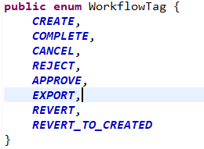

Workflow Definition:
- Contains workflow definition.
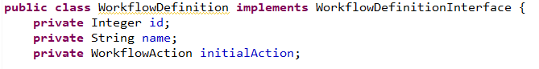
- Contains initial action.

Workflow Configurations using XML file:

Defining WorkflowDefination Bean:

<bean name="expenseWorkflowDefinition class="com.myreceiptsonline.workflow.WorkflowDefinition">

<property name="id" value="10001"/>
<property name="name" value="Expense approval workflow"/>
<property name="initialAction" ref="createExpenseAction"/>

</bean>

Defining WorkflowAction Bean:

<bean name="createExpenseAction" class="com.myreceiptsonline.workflow.WorkflowAction">

<property name="id" value="10003"/> # each action has id.
<property name="name" value="Create expense"/>
<property name="resultState" ref="createdState"/>
<property name="tags">
<set>
<value>CREATE</value>
</set>
</property>

<property name="commands">
<list>
<bean class="com.myreceiptsonline.receipt2erp.workflows.servicecommands.SetExpenseAccessWorkflowServiceCommand"> #refer this class !
<property name="addPermissions">
<map>
<entry>
<key>
<value>read</value>
</key>
<list>
<value>{employee.userName}</value>
</list>
</entry>
<entry>
<key>
<value>write</value>
</key>
<list>
<value>{employee.userName}</value>
</list>
</entry>
</map>
</property>
</bean>
</list>
</property>
</bean>

Defining WorkflowState Bean:

<bean name="createdState" class="com.myreceiptsonline.workflow.WorkflowState">

<property name="id" value="10001"/>
<property name="name" value="Waiting"/>
<property name="actions" ref="createdStateActions"/>

</bean>

List of Actions:

<util:list id="createdStateActions" value-type="com.myreceiptsonline.workflow.WorkflowAction">

<ref bean="completeExpenseAction"/>
<ref bean="cancelAction"/>

</util:list>

Mapping action to State:
<util:map id="workflowStateActions" key-type="java.lang.Integer" value-type="java.util.ArrayList">
<entry key="10001" value-ref="createdStateActions"/>
<entry key="10002" value-ref="completedStateActions"/>
<entry key="10003" value-ref="createdStateActions"/>
<entry key="10004" value-ref="accountingStateActions"/>
<entry key="10005" value-ref="approvedStateActions"/>
<entry key="10006" value-ref="revertCompleteActions"/>
</util:map>

Defining Domain Object:

<util:map id="definitionsByDomainObjectType" key-type="java.lang.Class" value-type="java.util.ArrayList" map-class="java.util.HashMap">
<entry key="com.myreceiptsonline.receipt2erp.domain.data.expense.ExpenseDetails" value-ref="expenseWorkflowDefinition"/>
<entry key="com.myreceiptsonline.receipt2erp.domain.data.expense.Expense" value-ref="expenseWorkflowDefinition"/>
</util:map>

Actions are getting executed by following way:
